
A 10
Sreenidhi Institute of Science & Technology
(An Autonomous Institution)
Code No: 102DS01
M. TECH. I – Year I – Semester Examinations, March, 2011 (Regular)
DIGITAL SYSTEM DESIGN
(Common to DSCE and VLSI & Embedded Systems)

Time: 3 Hours Max. Marks : 60

Note : No additional answer sheets will be provided.

* * * * *
Part-A (Objective Type)
Max.Marks:10
ANSWER ALL THE QUESTIONS. EACH QUESTION EQUAL MARKS.

1. What is a CLB.

2. Define fault dominance.

3. Give the difference between failure and fault.

4. Mention any two important applications of signature analysis.

5. Define distinguishing sequence.

6. What is circuit - test approach.

7. What are the types of test generation algorithms for PLAs.

8. Draw the basic model for fundamental mode circuits.

9. What is meant by dynamic hazard.

10. Draw the state diagram of 0101 sequence detector.

Part – B (Subjective Type)
Max.Marks: 50
Answer any Five. All questions carry equal marks.

1. a) Explain with an example, how a sequential circuit can be implemented by a CPLD. [ 4 ]

b) Draw the block diagram, state diagram of Binary divider and derive the SM chart from it. [ 6 ]

2. a) Draw the structure of a sequential programmable logic device. [ 2 ]

b) Implement the following three Boolean functions with a PLA. [ 8 ]

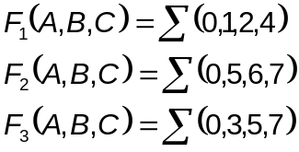
3. a) List out all the properties of Boolean differences. [ 4 ]

b) Find all the tests to detect S-A-0 fault at node h by applying path sensitization technique to the given circuit - 3 (b) [ 6 ]
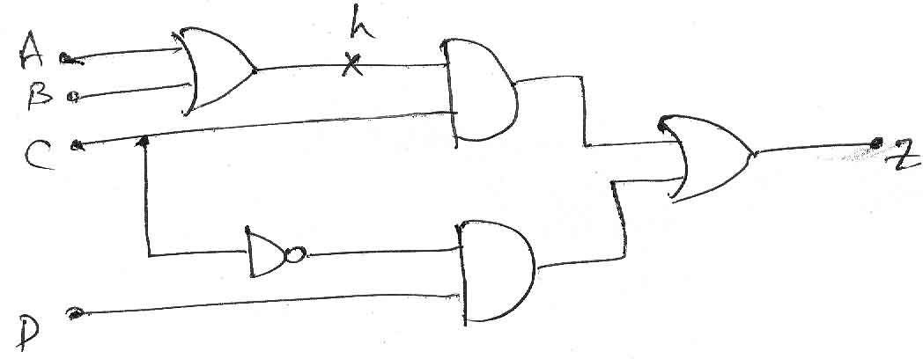
Circuit - 3 (b)

4. a) Explain how Random testing and transition count testing techniques can be employed in fault detection of digital circuits. [ 6 ]

b) Calculate the output signature for the LFSR shown in circuit 4 (b) for an input sequence "11010001". [ 4 ]
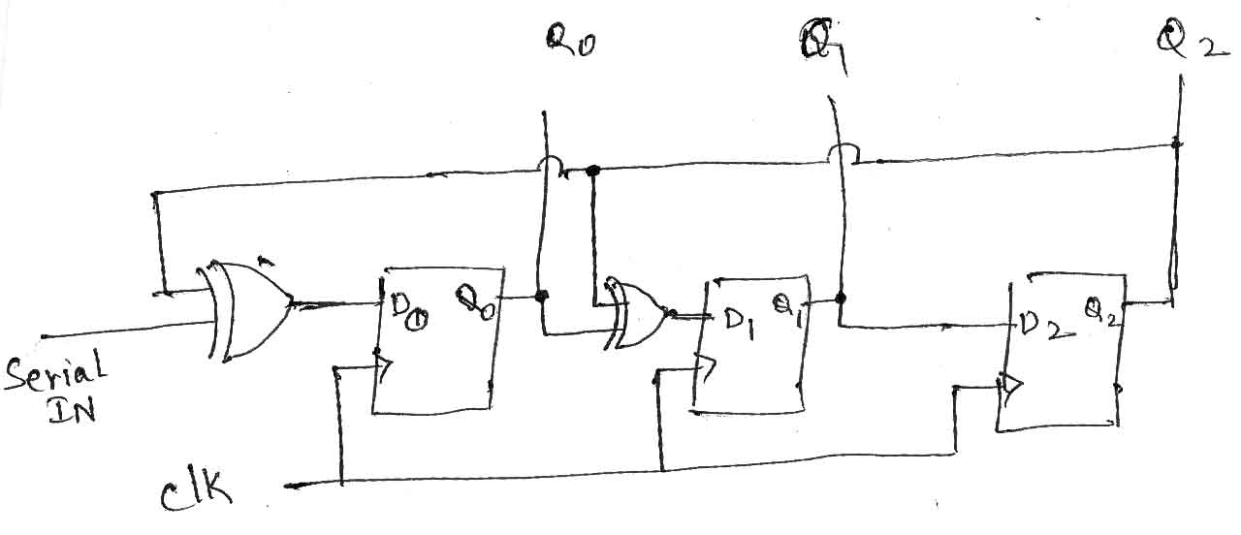
Circuit - 4 (b)

5. a) Explain the different phases in the fault detection experiment for sequential machines. [ 5 ]

b) Obtain the synchronizing sequence for the machine given below. [ 5 ]
PS | NS,z  X=0 | NS,z  X=1
A | B,1 | C,0
B | A,0 | D,1
C | B,0 | A,0
D | C,1 | A,1

6. a) State essential prime cube theorem. [ 2 ]

b) Minimize the PLA function f given below, using IISC - PLA minimization algorithm. [ 8 ]
f= 0200 + 1102 + 2201 +0011 + 0010

7. a) Discuss the capabilities and limitations of FSM? [ 4 ]

b) Realize the following switching function with a static Hazard free two level AND - OR and OR - AND circuit. [ 6 ]



